

**Batch: B1 Roll No.: 16010422234 Name: Chandana Ramesh Galgali**

**Experiment No.: 1**

**Aim:** To implement basic logic gates using Universal gates

**___________________________________________________________________**

**Resources needed:** Simulation Platform(CircuitVerse)

**Theory:**

Logic gates are the basic building blocks of any digital system. It is an electronic circuit having one or more than one input and only one output. The relationship between the input and the output is based on a certain logic. Based on this, logic gates are named as AND gate, OR gate, NOT gate etc

Classification: The two types of gate are:

1: Basic or Fundamental Gates:

* OR gate
* AND gate
* NOT gate

2: Derived Gates:

* NAND gate
* NOR gate
* X-OR gate
* X-NOR gate

**Basic Gates:**

* OR gate: The OR gate has two or more inputs but only 1 output. If any or all the inputs are high, the output is high. If all the inputs are low, the output is low.
* AND gate: The AND gate has two or more inputs but only one output. If any or all inputs are low then output is also low. When all the inputs are high then only the output is high.
* NOT gate: The Not gate is a gate with only one input and one output. The output is always in opposite state of an input. A NOT gate is also called as Inverter because it performs inversion.

**Procedure:**

1. Verify the truth tables of Basic and derived gates on the simulation platform.
2. Design Basic logic gates using Universal gates ((NAND and NOR) using simulation platform.
3. Verify the truth table for Basic gates by realizing them by using universal gates. (NAND and NOR) on simulator.
4. Paste the schematic of realization of basic logic gates using universal gates (to a pdf file.
5. Create a document with a table giving IC number used for each of the logic gate studied in the experiment, Outcomes , Conclusion.
6. Please note every document uploaded as Lab Writeup should be labelled as Exp_<No>_<RollNo.pdf

**___________________________________________________________________________**

**Observations and Results:**

1. Verify the individual circuit using truth table method. (showing intermediate outputs).
2. Design basic logic gates using Universal Gates.

**Outcomes:**

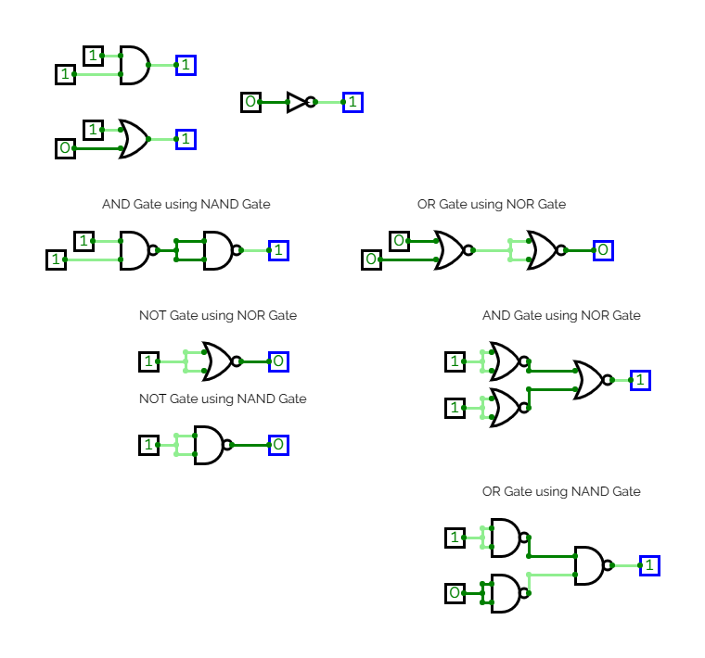

**___________________________________________________________________________**

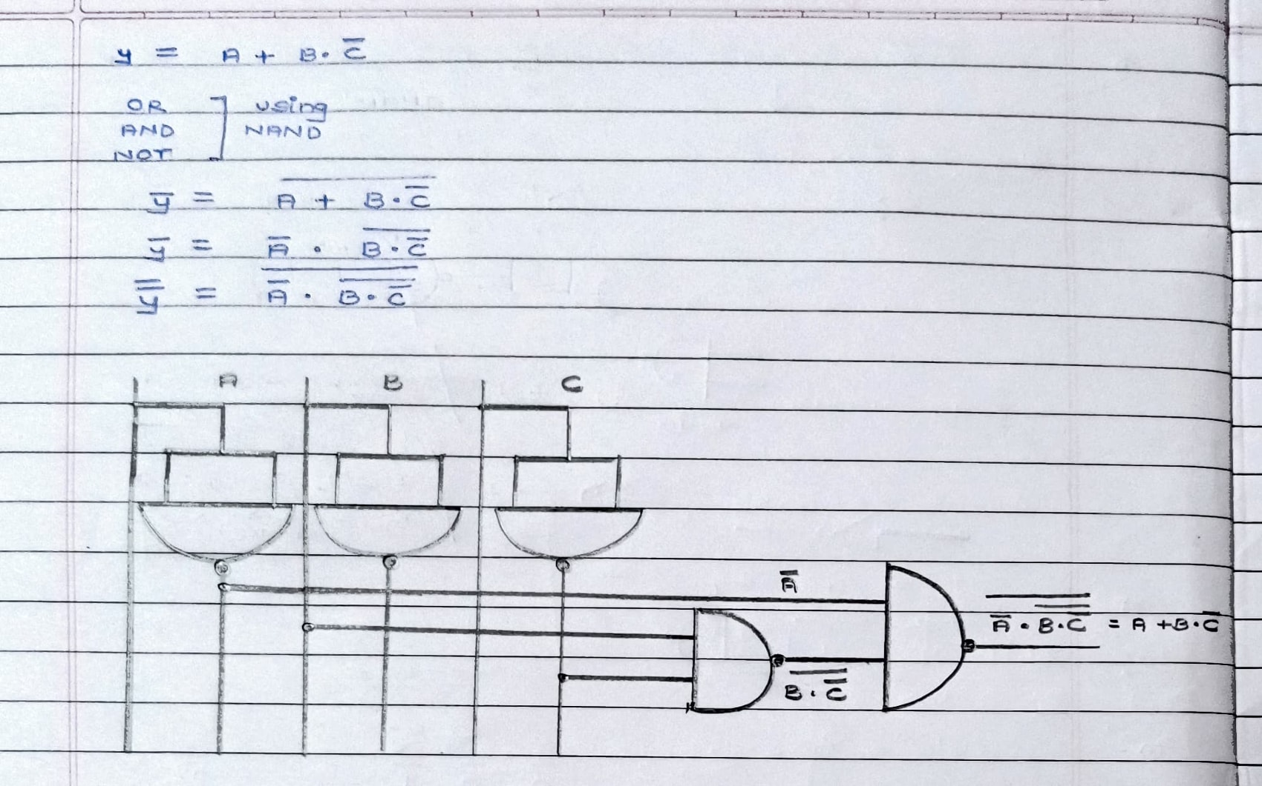

**Conclusion:**

All the basic logic gates have been successfully verified on CircuitVerse. We could successfully implement basic logic gates using Universal gates.

**Grade: AA / AB / BB / BC / CC / CD /DD**

**Signature of faculty in-charge with date**

**___________________________________________________________________________**

**References:**

**Books/ Journals/ Websites:**

1. R. P. Jain, “Modern Digital Electronics”, Tata McGraw Hill.
2. http://www.allaboutcircuits.com/worksheets/basic-logic-gates/